**STA 5107 Homework Assignment #7**

Zhengwu Zhang

Problem 1.

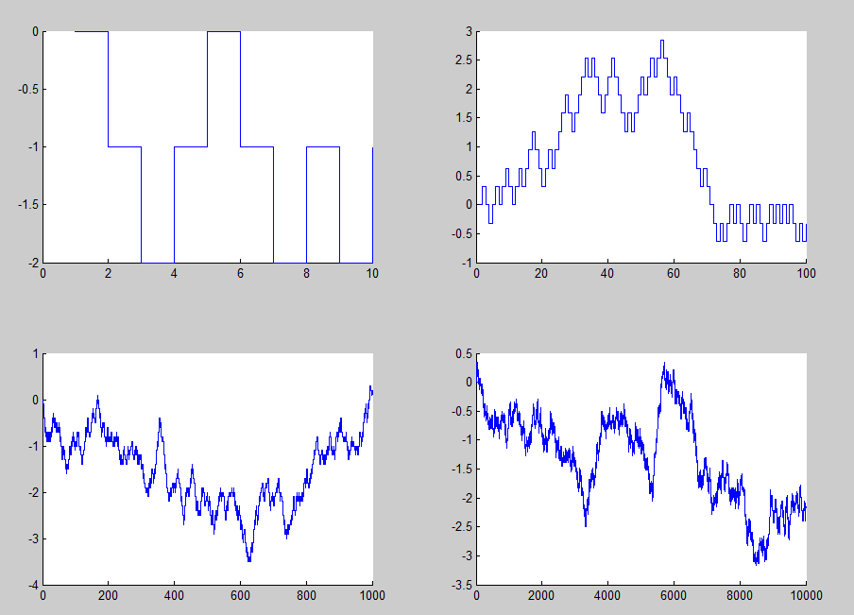

Figure 1. Random walk

Matlab Program:

%answer for HW7

%problem 1

clear all;

close all;

t = [1 0.1 0.01 0.001]

for n=1:4

T = t(n);

%T = 0.1; 0.01; 0.001;

a = 1.0;

s = a*sqrt(T)

N = 10/T;

walk(1) = 0;

for i=2:N

U = rand;

if ( U>0.5)

walk(i) = walk(i-1) + s;

else walk(i) = walk(i-1) -s;

end;

end;

subplot(2,2,n)

hold on,stairs(walk);

end;

Problem 2

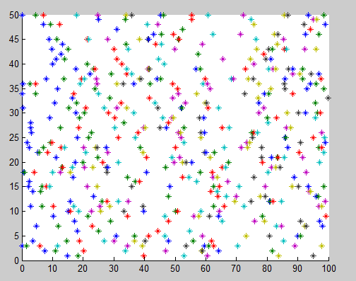

Figure 2. Homogeneous Poisson Process

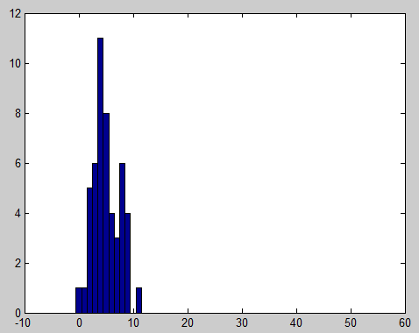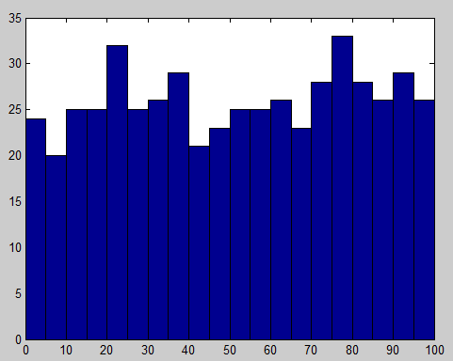

Figure 3 Histogram of the events happens in [10, 60] Figure 4. Histogram of Random Variables

Do the KS test, the results indicates that the events is Poisson Distribution in the interval [10 60]

We get h=0;

Matlab Program:

%answer for HW7

%problem 2

clear all;

close all;

namta = 0.1;

%Generate 50 samples from exponential distribution

e_mu = 1/namta;

e_s = exprnd(e_mu, 20,50);

for i=1:50

t(:,i) = cumsum(e_s(:,i));

temp = t(:,i);

P_t{i} = temp(temp<100);

hold on, plot(P_t{i}',i,'*')

end;

figure(2);

PP = [];

for i = 1:50

PP = [PP P_t{i}'];

end

hist(PP,2.5:5:97.5);

figure (3);

for i=1:50

r(i) = sum(P_t{i}>10 & P_t{i}<60);

end;

hist(r, 0:50);

% hold on, plot(P_t{i},i,'*')

% axis([0 100 0 50])

% end;

%do ks test

mu = mean(r);

x = 0:50;

est_cdf = poisscdf(x, mu);

[h,p] = kstest(r, [x' est_cdf']);

Problem 3.



Figure 5

Matlab Code:

%%answer for HW7

%problem 3

clear all;

close all;

%interval = 0.1

T = 10;

t = 0:0.1:T;

namta = 2 + sin(t) + sin(2.*t)./2;

%F(s)

f = inline('5/4 + 2*s - cos(s) - cos(2*s)/4');

df = inline('2 + sin(s) + sin(2*s)/2');

% sample {t1, t2, ... tn}

M = 30;

for i=1:M

% sample {t1, t2, ... tn}

s(i) = poissrnd(f(T));

x = rand(1,s(i))*f(T);

tmp{i} = sort(x);

%out put f-1(t);

%N-R algorithm

L = length(tmp{i});

for j = 1:L

x = T/2; % initial position

ind = 0;

while ind < 100

ind = ind+1;

x_new = x - (f(x)-tmp{i}(j))/df(x);

d = abs(x_new-x);

if d<1e-3;

break;

end

x = x_new;

end

ipp{i}(j) = x;

end;

end;

subplot(4,1,1);

plot(t, namta);

for i = 1:30

subplot(4,1,2:4)

hold on,plot(ipp{i},i,'*');

end;

Problem 4: